Title: Desk Workout and Advice |  | Date: | Feb 2017

We all know that sitting for long periods is bad for your back. However it is often difficult to break the routine of long periods sat in one position or hard to discipline yourself to do a few exercises regularly. Maybe you feel self-conscious exercising at your desk. Believe me a couple of minutes is time well spent and your colleagues will be envious rather than mocking. Perhaps you can even be the catalyst and everyone will join in with you as the lead.

Some of the problems that occur when we spend too long sitting are shown below.

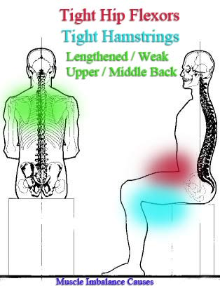
In addition to the points shown in the
image the front of the chest becomes
tight and the arms internally rotated.

The head often pokes forward (forward head posture)

When we sit for too long in one position
the circulation becomes sluggish.

Here are a few tips regarding posture when sat at a desk.

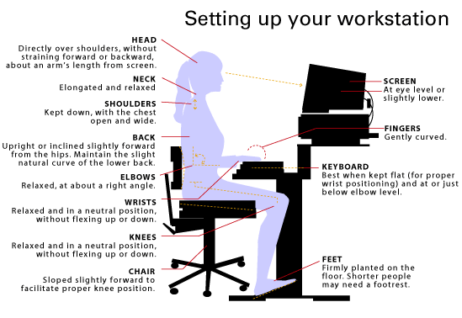

Even if your posture is great you should not maintain one position for too long. Try to move at least every hour. If possible set your watch to remind you to do a quick few exercises every hour.

Finally here are a few exercises for you to try.

LIFT LEG AND TWIST

This exercise is great for mobilizing the thoracic spine and stretching the hamstrings
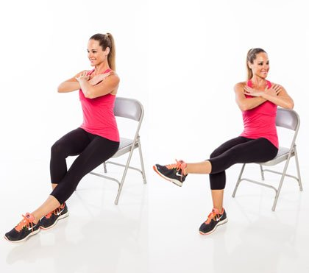

Sit slightly forward on the chair.
Cross your arms across your chest and lengthen through
the spine (remember not to shrug your Shoulders).
As you extend the right leg rotate to the right.
Repeat to the other side
Do at least 5 times each way.

ARM AND LEG TONING / CIRCULATION

This exercise will get your blood circulating in the areas that have been static while you have been sitting – the thighs, buttocks and shoulders
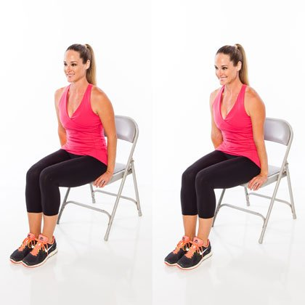
Sit slightly forward on the chair
Place your hand either side of your thighs
And your feet flat and knees together.
Squeeze your knees together and contract your
buttocks as you push down through your
hands to extend your elbows.
Feel your shoulders stretch down away from
your ears and lengthen through the top of the head
Repeat 10 times.

SPINE TWIST AND STRETCH
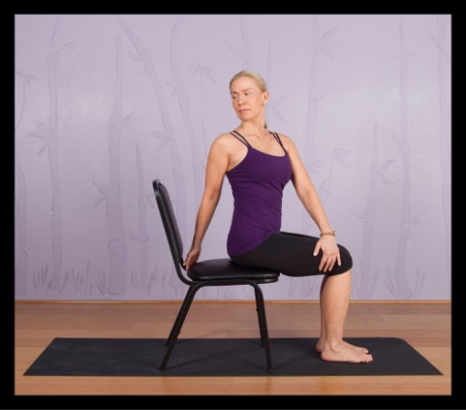
Sitting on the edge of your chair with your feet and knees together.
Place your left hand on your right knee and your
Right hand at the back of the chair.
Sit up tall through your spine and rotate round to the right.
Breath out to rotate round and breath in to return to the front.
Repeat turning 5 times to each side.
Breathing slowly and deeply whilst doing this exercise is important since it is a refreshing change for the body from the shallow breathing that we adopt whilst seated.

HIP STRETCH
Whilst sitting the hips are fixed in flexion and in some cases a degree of internal rotation. This exercise opens out and stretches the hips.

Sitting on the edge of your chair cross one leg over the other
resting the ankle on the opposite knee.
Lower the elevated knee as far as you can then lean forward
at the waist, keeping your head up.
Lean forwards to a stretch point then back 5 times each side

THORACIC SPINE EXTENSION

This exercise is pictured using a ball but can be performed without.
Sitting in a chair with your feel flat on the ground and knees apart.
Sit tall through the spine and place your hands at the base of your skull.
Engage your abs to support your lumbar spine and then lean backwards at the thoracic spine either over the ball or the back of the chair.
Support your head with your hands and be careful not to let your chin poke forwards
Hold for 10 seconds

SHOULDER CIRCLES AND EXTERNAL ROTATION

These exercises are straight from our warm up routine so don’t need pictures.
- Sitting upright in your chair, stretch tall through your head. Feeling length through your neck throughout, circle your shoulders backwards 5 times then forwards 5 times
- Sitting as above bend your elbows to a right angle and glue your elbows to your sides. Rotate your arms out sideways and brace your shoulders down and together, repeat 10 times.

STAND UP SIT DOWN

Place your feet hip distance apart and without using your hands simply stand up and sit down again 10 times. This will extend your hips and get your circulation going.

NO EXCUSES!

I have just done these exercises and they took me 4 minutes. The benefits are well worth 4 minutes out of each hour. Use the 4 minutes as time to clear your head and restart your circulation.

NB: These exercises are best done on a static chair. If your chair has castors take extra care.

